1.Define business.What are the elements in business?
Ans : Business is an economic activity, which is related with continuous and regular production and distribution of goods and services for satisfying human wants.
The elements of business are :
- Product.
- Customer Service.
- Systems.
- Time Management.
- Team Management.
- Marketing.
- Finances.
- Leadership.

2.What is industry?Discuss in brief different categories of secondary industry.

Ans: industry, group of productive enterprises or organizations that produce or supply goods, services, or sources of income. Industries are generally classified as primary, secondary, tertiary, and quaternary;

Secondary industry: This sector, also called manufacturing industry, (1) takes the raw materials supplied by primary industries and processes them into consumer goods, or (2) further processes goods that other secondary industries have transformed into products, or (3) builds capital goods used to manufacture consumer and nonconsumer goods.

Secondary industry may be divided into heavy, or large-scale, and light, or small-scale, industry.

Large Scale industries: Large scale industries employ a large number of persons and consume vast quantities of power. Huge capital investment is needed. Iron and steel industry, textile industry etc.
Small scale industries: Small scale industries (SSI) are those industries in which manufacturing, providing services, and productions are done on a small scale or micro scale. For example: Napkins, tissues, chocolates etc.

3.How can ecommerce help to eliminate the barrier for performing business in Bangladesh?
Ans: Nowadays e-commerce is a very versatile form of business. For e-commerce we can easily eliminate the barrier in performing business.In e-commerce customers and service providers of a business organization can easily connect with each other.Basically a customer can easily choose any product online and place orders.So they don't have to face any hesitation to choose any product like offline market.That’s why business comes to a simpler form and barrier gets eliminated.

4.What are the factors that should be considered to starting a business?
Ans:Factors to be considered for starting a business are given below:
1.Selection
2.feasiblity report
4.Demand of product
5.Size of Business
6.Location
7.Government policy
8.Availablity of raw material,machines,labor and power resources

5.Describe in brief,function of business organization.
Ans:Following are the main functions of a business :
1.Productions:Production of goods and services is the first main function of business which should be regular and satisfy human needs.
2.Sales: the sale is another important function which is two types:
a)Cash sales,
b)Credit sales .
3 .Finance : Finance is required for establishment and expansion of business sourced from a)owner's capital ;b)Borrowed funds
4. Management function based on a)planning, b)organizing ,c)leading ,d)controlling, e)staffing.
5. Innovation and Research: To increase production and maintain the needs in large scale a business must need innovation of new product and research the customers need.
6 .Accounting
7 .Marketing
8. Quality Improvement and motivation

6.What is the sole proprietorship form of business?(or what is one man business)
Ans:A sole proprietorship form of business or one man business is a form of business in which an individual produces independently with own capitals.

7.What is a T account?
Ans:A T-account is an informal term for a set of financial records that use double-entry bookkeeping.It is called a T-account because the bookkeeping entries are laid out in a way that resembles a T-shape.

8.Define Break Even Chart.
Ans:A breakeven chart is a chart that shows the sales volume level at which total costs equal sales. Losses will be incurred below this point, and profits will be earned above this point. The chart plots revenue, fixed costs, and variable costs on the vertical axis, and volume on the horizontal axis.
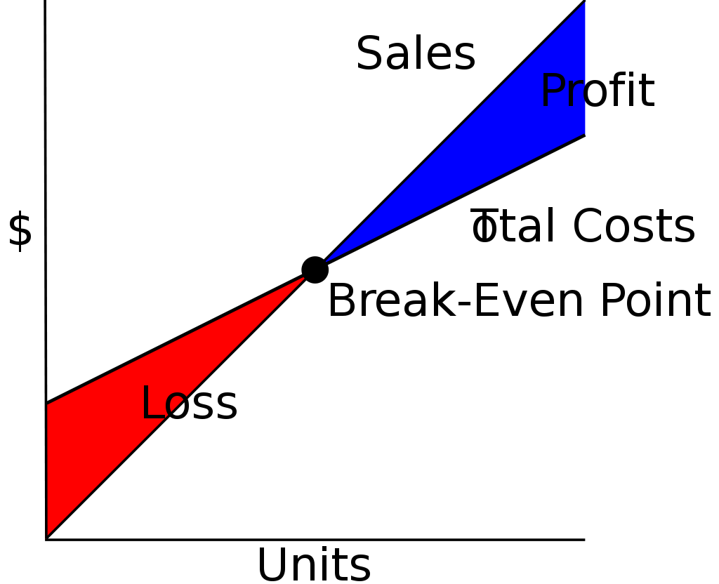
9.What do you mean by accounting cycle?
Ans:The accounting cycle is the process of accepting, recording, sorting, and crediting payments made and received within a business during a particular accounting period.
The accounting cycle is a standard, 8-step process that tracks, records, and analyzes all financial activity and transactions within a business. It starts when a transaction is made and ends when a financial statement is issued and the books are closed.
10.what is motivation ?why is it essential in an organization?
Ans:
Motivation is the process that initiates, guides, and maintains goal-oriented behaviors

Importance of Motivation in an Organization.

1. Increases Productivity

Motivation is a process that leads to an increase in the productivity of the employee.. A well-employee will be willing to put in more effort towards the betterment of the organization than another disheartened employee.

2. Ensures Organizational Efficiency

Motivation plays an important role in changing the attitudes of the employees in the organization. The presence of such a favorable attitude allows the organization to thrive and be successful.

3. Ensures Loyal Workforce

A well-motivated workforce is a loyal workforce. Motivation thus reduces employee turnover and reduces the need for constant induction of new employees.

4. Ensures a Reactive Workforce

Adapting to changing business environments is an important feature of any successful business. Motivation makes sure the employees can adapt.

5. Facilitates Direction

Motivation as already mentioned is a vital part of the direction. The direction is a process that involves directing or initiating action according to a plan drawn up and requires the employees to work wholeheartedly with commitment and loyalty.

